Rehabilitation of 6 Bridges
over Watts Branch

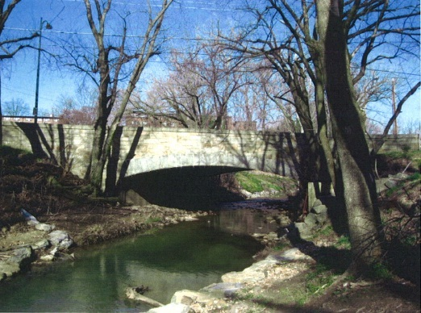
The Rehabilitation of six (6) bridges over Watts Branch improvement project will include infrastructure enhancements at Gault Place, 44th Street, 48th Place, 55th Street, 58th Street and Division Ave, N.E bridges. Initial construction activities will begin March 31, 2014 with an expected completion period of 10 months, weather permitting
6 Bridges will be rehabilitated over Watts Branch NE to Begin Monday, March 31 2014. The six (6) bridges are located on the following streets:
- Gault Place, NE
- 44th Street, NE
- 48th Place, NE (resurfacing)
- Division Avenue, NE
- 55th Street, NE (resurfacing)
- 58th Street, NE

During construction, up to four bridges may be closed at one time, with some bridges remaining open for pedestrian access and adequate vehicle detours. The initial bridges slated for closure include Gault Place, 48th Place (open to pedestrian access only), and 58th Street. Both Gault Place and 58th Street will be closed to all pedestrian and vehicle traffic on or about April 14th, 2014. 48th Place will have access for pedestrians open at all times during construction.

Bridge enhancements will include the following:
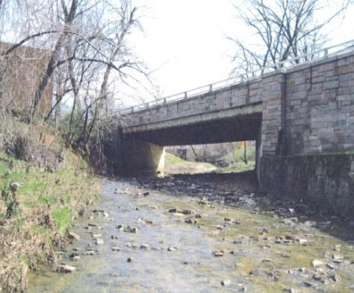
- Replacing the bridge decks,
- Replacing the pedestrian railings,
- Upgrading the storm drain inlets
- Upgrading handicap ramps
- Widening sidewalks

Motorists, pedestrians, and cyclists are urged to stay alert and use caution when traveling through the work zone. Construction activities will take place Monday through Friday, between the hours of 7 a.m. – 7 p.m., with additional hours scheduled on nights and weekends as needed.

For additional details please contact the Project Manager Phillips Folayan at 202-49-7804 or the project’s public outreach office at 6BridgesDC@gmail.com.

