Parking Meter Rate Change in Penn Quarter/Chinatown Area FAQs
ParkDC: Penn Quarter/Chinatown is a pilot program to provide real-time parking availability information and adjust on-street parking meter rates so more spaces are available. The following is a list of frequently asked questions.
Why are parking meter rates changing?
Meter rates are being adjusted to ensure that more on-street parking spaces are available by balancing parking demand across the pilot study area. Parking meter rates for blocks with high demand will likely increase while rates for blocks with low demand will likely decrease. The objective is to increase the availability of on-street parking and reduce occurrences of double-parking and “circling the block.”
Where are meter rates changing?
All meters affected by the pilot are between 11th Street NW and 3rd Street NW and between H St NW and E St NW, outlined in red on the map below.

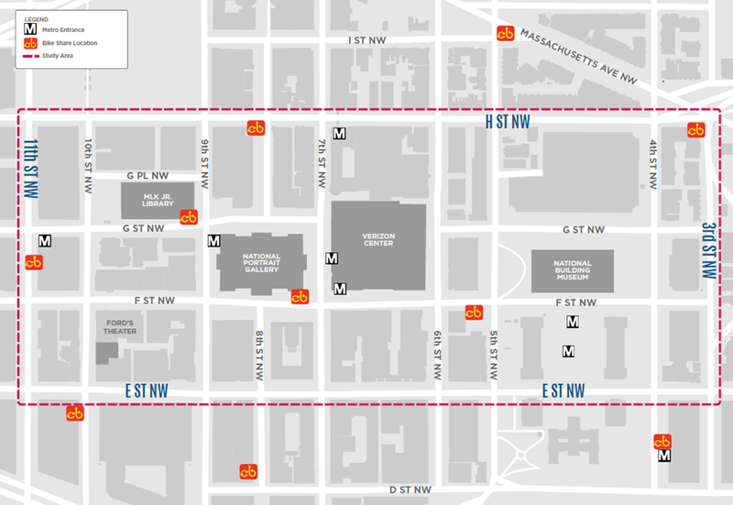
At what geographic level are the parking meter rates being adjusted?
Parking meter rates are being adjusted at the block face level, so all the spaces on one side of the street will have the same price on each block.
Does DDOT plan to expand this program?
DDOT will carefully evaluate the effectiveness of this pilot project. After conducting a thorough evaluation, including the collection of feedback from the public, DDOT will review items that are deemed cost effective and user-friendly and may apply them to other locations in the District.
How do you determine whether to raise or lower the parking meter rate?
Parking occupancy data gathered from in-ground sensors and payment transaction data, supplemented with historic usage data, is used to determine demand for parking along a particular block face. In areas with high demand, rates will rise. In areas with low demand, rates will lower.
When will the first rate adjustment take place?
The first meter rate adjustment will go into effect beginning Monday, October 17, 2016. The next rate adjustment is scheduled to occur in January 2017.
How often do parking rates change?
The parking meter rate is slated to be adjusted every three months.
How will I know when meter rates change?
All rate adjustments will be posted on the project website in advance of the change.
How will meter rate changes affect the rates at parking garages?
ParkDC: Penn Quarter/Chinatown has no control over the price to park in area parking garages, and any rate changes made in area parking garages will be at the discretion of the individual garage operator.
Will parking meter time limits also be affected?
Changes to parking meter time limits will be explored, especially if lowering parking meter rates does not result in higher demand. However, at this time there are no plans to modify time limits.
Where does revenue from the project go?
Parking meter and ticket revenue covers the operating cost of the program and remaining revenue is allocated towards the District’s share of WMATA costs.
Is it really safe to use my credit card at the meters?
Yes. Meters meet the Payment Card Industry’s strict Data Security Standards. More information on these standards can be found on the PCI website.
How can I get parking information on my phone if I don’t have an iPhone or Android?
Parking information will be available on a website as well as on mobile apps. For those who do not use smart phones, information regarding parking and payment will be displayed on parking meter decals as well as the meter start-up screen. The website and apps are coming soon.
Will the parking meter rate be the same all day?
Not necessarily. Pricing is set based on a time-of-day schedule similar to the Metro system. Parking meter rates during peak periods of parking demand will be higher than off-peak periods. On weekdays, there are three time periods: 7am – 11am, 11am – 4pm, and 4pm – 10pm. On Saturdays, the rates will be the same all day. The rate schedule will be updated every three months.
As part of the first pricing adjustment, parking meter rates on individual block faces will either decrease to $2.00 per hour, stay the same at $2.30 per hour, or increase to $2.75 per hour on the 91 block faces located within the Penn Quarter and Chinatown neighborhoods. Blocks identified for parking meter rate adjustments are shown in the figure below.
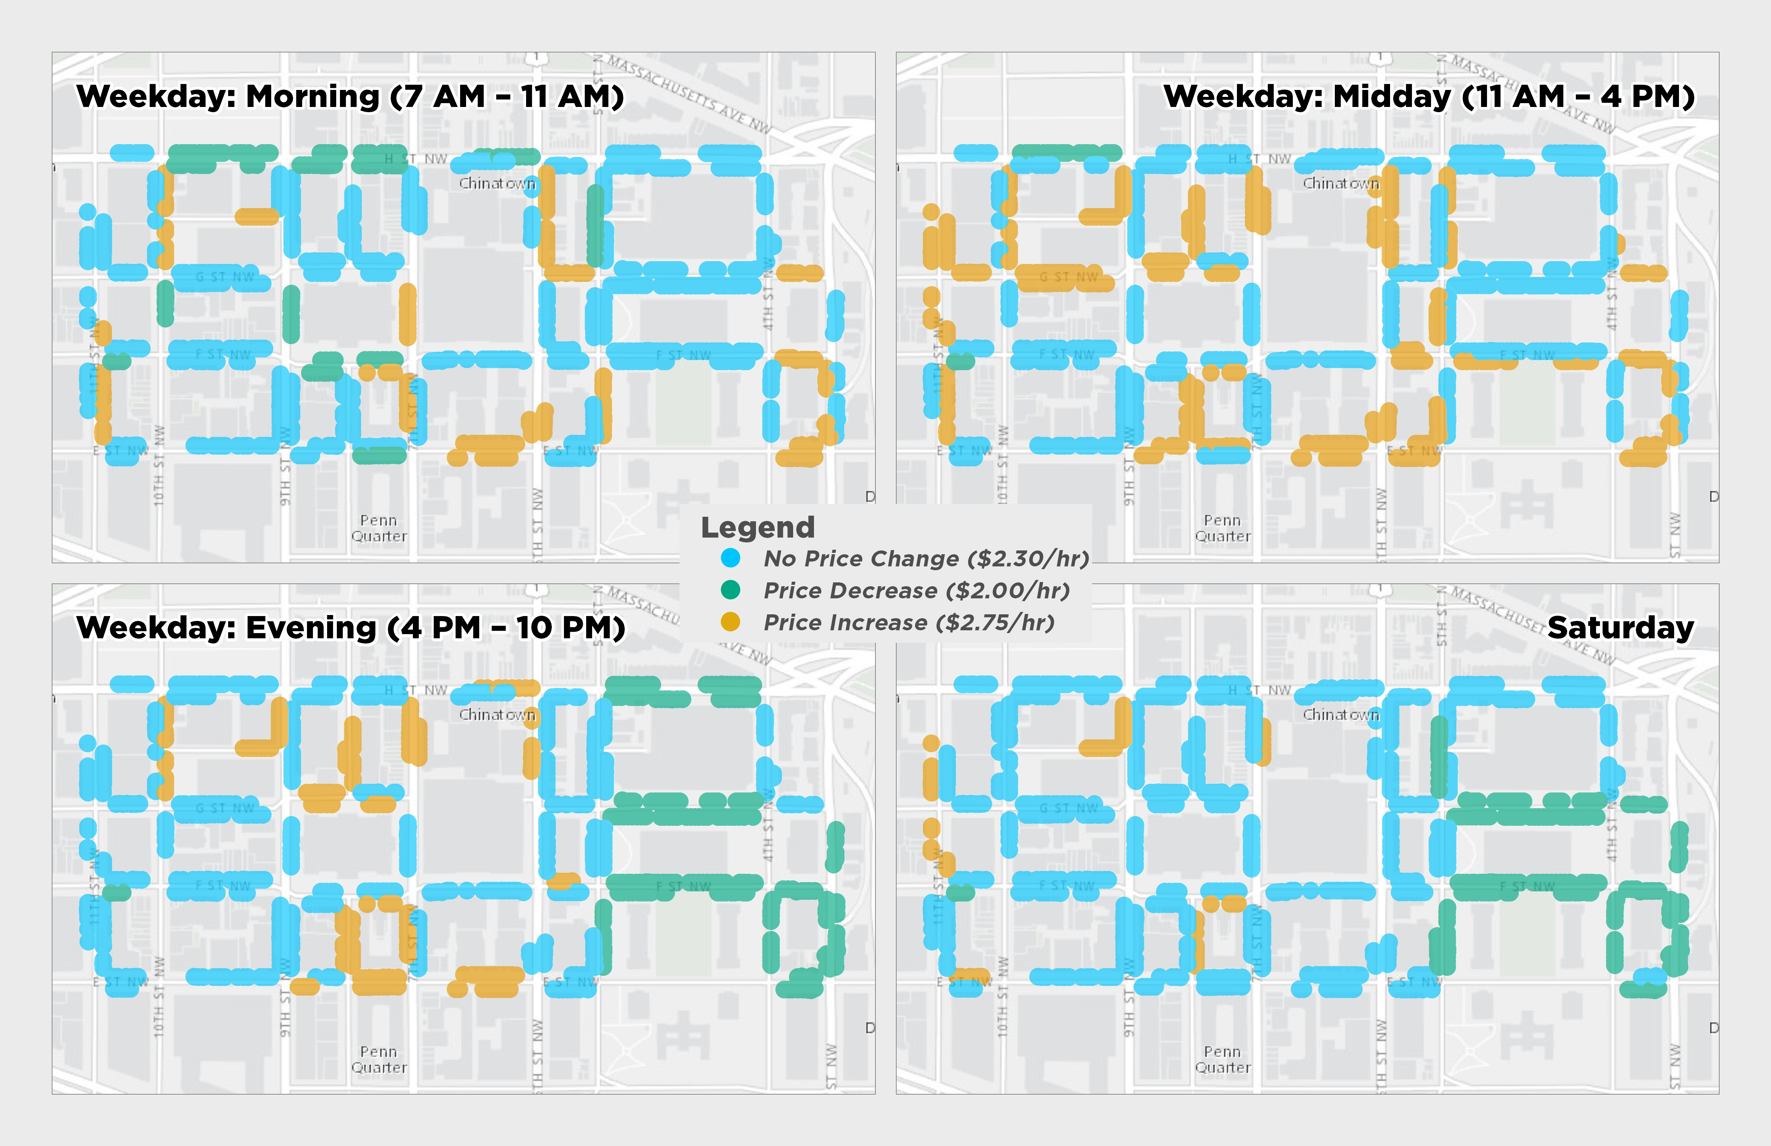
How much will I pay if my parking stay overlaps time periods?
You will pay for the amount of time you are parked in each time period. For example, if you are planning to park for two hours, with one hour in the morning time period, and one-hour in the midday time period, you would pay for one hour at the morning time period parking meter rate, and for one hour at the midday parking meter rate. The meter will calculate this prorated rate automatically during the payment process.
How will I know the meter rate of where I am going to park?
Meter rate information will be displayed on parking meter decals as well as the meter start-up screen based on time of day and block face. Meter rate information will also be available via mobile apps and the project website.
Will I know exactly which spaces are available?
Parking availability information will be displayed at a block face level only to minimize capital expenses associated with installing parking occupancy sensor equipment.
Do I still have to return to my car to display a receipt from the parking meter?
No, in the pilot area you do not need to display a receipt in your window. You can pay by either entering the parking space and zone number at a multi-space parking meter, or by entering the information in your ParkMobile smartphone app.
How will I know my parking space number?
Poles marking the space numbers are placed on blocks with multi-space meters. For single spaces meters, a sticker has been placed on the meter.

